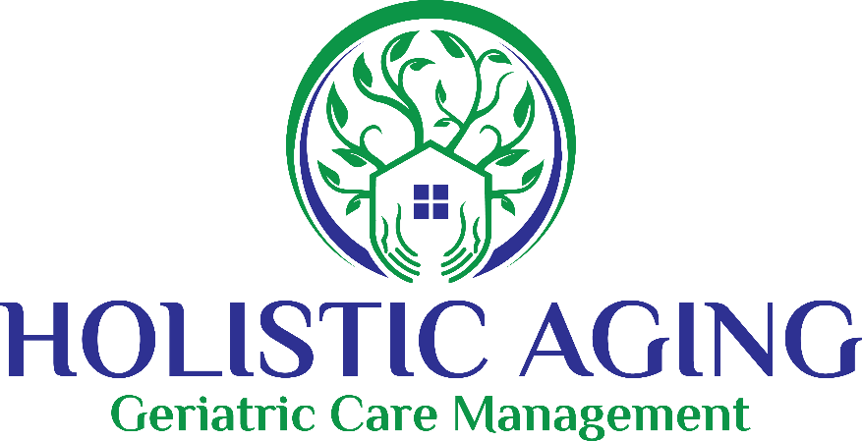
HIPAA Right of Access Form

I, __________________________ direct my health care and medical services providers and payers to disclose and release my protected health information described below to:

Company Name: Holistic Aging/Options for Elder Care Life Care Manager

Name:___________________________________ Cell Phone: ___________________

Relationship: _____________________________ E-Mail: _______________________

Health Information to be disclosed upon the request of the person named above -- (Check either A or B):
 | A. Disclose my complete health record (including but not limited to diagnoses, lab tests, prognosis, treatment, and billing, for all conditions) OR
 | B. Disclose my health record, as above, BUT do not disclose the following (check as appropriate):   Mental health records   Communicable diseases (including HIV and AIDS)  Alcohol/drug abuse treatment  Other (please specify):

______________________________________________________

Form of Disclosure (unless another format is mutually agreed upon between my provider and designee):  An electronic record or access through an online portal
 Hard copy

This authorization shall be effective until (Check one):
 All past, present, and future periods, OR
 Date or event:__________________________________________________
unless I revoke it. (NOTE: You may revoke this authorization in writing at any time by notifying your health care providers, preferably in writing.)

_____________________________________________ _____________________
Name of the Individual Giving this Authorization Client's date of birth

_____________________________________________ _____________________
Signature of the Individual Giving this Authorization Date

Note: HIPAA Authority for Right of Access: 45 C.F.R. § 164.524

Resource provided by the ABA Commission on Law and Aging | www.americanbar.org/aging

